Security Checks at Runtime and Compile Time
The sample application includes 6 tests to simulate some of the errors programmers may commit, or the results of malicious input to a program that is too trusting:
- Overwrite a buffer by running a loop too many times. Since only one buffer is defined, the overwrite affects the rest of the stack including the return address.
- Overwrite a buffer when another buffer is also on the stack.
- Underwrite a buffer.
- Use an uninitialized variable
- Perform a cast that may lose information
- Use an uninitialized variable in more complex ways

Some of these tests are relevant to both the /GS and /RTC options.

/GS – Buffer Security Check

When you compile with /GS, code is inserted to detect buffer overruns that may have overwritten the function’s return address. A dialog warns the user and then the program is terminated. In this way, an attacker cannot take control of the application. Optionally, a custom error handling routine can be written to handle the error in lieu of the default dialog box.

A special “cookie” (series of bytes) is inserted just before the return address so any buffer overrun will change it. Just before the function returns the value of the cookie is tested. If it has changed, the handler is called. A server or service might require different handling than displaying a dialog; see MSDN for more details on writing your own handler.

The cookie is generated by the C runtime during start up so attackers will not know its value, and it will be different each time the program is run. Because it uses the CRT, it is important that the C runtime initialization does not happen twice and regenerate the cookie, as false positives will occur.

This compiler option is meant for released code. The command line to compile the sample code for testing is:

cl /O2 /ML /GS /EHsc GS-RTC.cpp

(The /O2 option turns on optimization. This is not a debug build.) Running this command creates gs-rtc.exe.

Test 1 is designed to show what /GS does:

void Test1()
{
char buffer1[100];

for (int i=0 ; i < 200; i++)
{
buffer1[i] = 'a';
}

buffer1[sizeof(buffer1)-1] = 0;

cout << buffer1 << endl;
}

The for loop executes too many times and is going to overrun the return address and a lot more. To run test 1, compile with /GS then issue this command:

gs-rtc 1

This dialog appears:

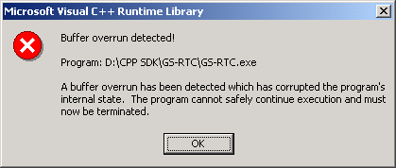

For comparison, compile the same code without /GS:

cl /Od /MLd /EHsc /ZI GS-RTC.cpp /link

Run the test again and see this dialog:

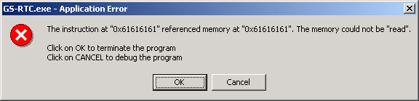

An attacker using a buffer overrun attack overwrites the return address with a carefully thought out one that would give the attacker control. This sample just writes ‘a’s (hex 61s) over the return address.

/GS will not detect overruns that do not overwrite the return address but corrupt other memory and cause inaccurate results. Try running test 2 with either of the compile commands shown so far.

gs-rtc 2

Even though test 2 overwrites memory, /GS does not detect it. In the optimized release build of this particular code, the assignment of the null terminators is moved after the loop so there is no consequence of the overwrite. This would not be true in general.

/RTC

RTC stands for RunTime Checks. There are a series of sub options with RTC. Unlike /GS, /RTC is designed for debug builds. It does not work with optimized code. Like /GS, you can write your own handler if you don’t like the default dialog box.

When you are debugging an application with Visual Studio, the RTC dialogs provide you with the option of debugging the application at the point of error. As well, you can create several configurations in Visual Studio that build with different combinations of options, so that you always use /GS with release builds and one or more /RTC options with debug builds, for example.

/RTCs - Stack frame run-time error checking

This option does several things that help to protect the stack from corruption.
- All local variables are initialized to non-zero values each time the function is called. This prevents inadvertent use of values on the stack from previous calls.
- The stack pointer is verified to checks for corruption such as that caused by defining a function as __stdcall in one place and __cdecl in another.
- Detect overruns and underruns of local variables. This differs from /GS because it is available only in debug builds and it detects corruption on either end of a buffer and for all buffers.

cl /Od /MLd /ZI /EHsc /RTCs GS-RTC.cpp

This command turns off optimization (/Od) and sets the _DEBUG preprocessor definition.

After compiling the sample with this command line, try test 1 again. It will catch the overwrite.

Test 2 illustrates stack overrun that doesn’t involve the return address:

void Test2()
{
char buffer1[100];
char buffer2[100];

buffer1[0] = 0;

for (int i=0 ; i <= sizeof(buffer2); i++)
{
buffer2[i] = 'a';
}

buffer2[sizeof(buffer2)-1] = 0;

cout << buffer2 << '-' << buffer1 << endl;
}

This loop overruns buffer2 by one character because it uses <= instead of a <. It will overwrite the first character of buffer1. When compiled with the /RTCs compiler switch and run with “gs-rtc 2”, this dialog appears:

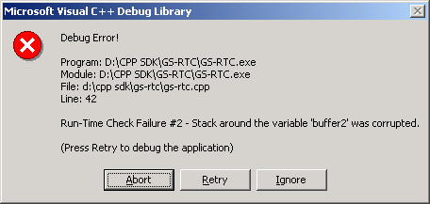

Test 3 demonstrates an underrun:

void Test3()
{
char buffer1[100];
char buffer2[100];

memset(buffer1,'a',sizeof(buffer1)-1);
buffer1[sizeof(buffer1)-1]=0;
memset(buffer2,'b',sizeof(buffer2)-1);
buffer2[sizeof(buffer2)-1]=0;

*(buffer1-1) = 'c';
cout << buffer1 << endl;
cout << buffer2 << endl;
}

(To run test 3, use the command line “gs-rtc 3”.) The last byte of buffer2 is overwritten in this case and the dialog finds the problem around buffer1. Without the runtime checks, the output of this test is:

aaaaaaaaaaaaaaaaaaaaaaaaaaaaaaaaaaaaaaaaaaaaaaaaaaaaaaaaaaaaaaaaaaaaaaaaaaaaaaaaaaaaaaaaaaaaaaaaaaa
bbbbbbbbbbbbbbbbbbbbbbbbbbbbbbbbbbbbbbbbbbbbbbbbbbbbbbbbbbbbbbbbbbbbbbbbbbbbbbbbbbbbbbbbbbbbbbbbbbbcaaaaaaaaaaaaaaaaaaaaaaaaaaaaaaaaaaaaaaaaaaaaaaaaaaaaaaaaaaaaaaaaaaaaaaaaaaaaaaaaaaaaaaaaaaaaaaaaaaa

Because the underwrite clobbered the terminator of buffer2, all use of buffer2 as a null-terminated string will get a string twice as long as expected.

Test 4 shows how the /RTCs option sets uninitialized variables to a “flag” value:

void Test4()
{
unsigned int var;

cout << hex << var;
}

Run test 4 after compiling with /RTCs and you will see the hex value cccccccc. Compile without /RTCs and you will see the random value that was left on the stack.

/RTCc – Detects Assignments that resulted in data loss.

This option inserts code to alert you when an assignment results in data loss, so you can be sure that all the casts you make to smaller types never lose data. Test 5 illustrates this.

void Test5(int value)
{
unsigned char ch;
ch = (unsigned char)value;
}

Compile this code with the following command line

cl /Od /MLd /ZI /EHsc /RTCc GS-RTC.cpp

Run this with another number on the command line. For example, this command triggers the error:

gs-rtc 5 300

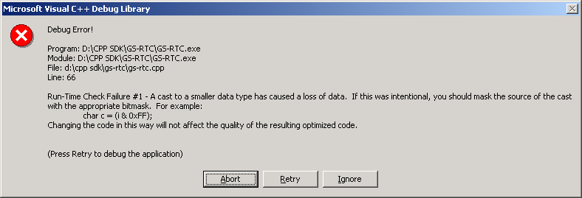

The maximum value that an unsigned char can hold is 255, so putting 300 into it causes a loss of data. Run again with “gs-rtc 5 200” and there will be no error.

If you want to cast into a smaller type and deliberately lose the upper bits, use a mask, like this:

ch = (unsigned char)(value & 0xFF);

/RTCu – Report variable use without initialization

This option warns when a variable is accessed without being initialized. Test 6, which has three subtests, illustrates this:

void Test6(int value)
{
int uninitialized;
int var;

switch (value) {
case 3:
uninitialized = 4;
case 2:
var = 5 * uninitialized;
break;

case 1:
int *var2;
var2= &uninitialized;
var = 5 * uninitialized;
break;
}
}

(Notice that case 3 falls through to case 2.) Compile this code with the following command line

cl /Od /MLd /ZI /EHsc /RTCu GS-RTC.cpp

Running “gs-rtc 6 2” causes a dialog:

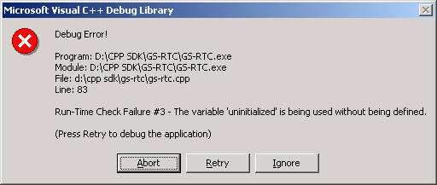

Running “gs-rtc 6 3” will not cause a dialog, because the variable gets initialized. However, “gs-rtc 6 1” gives no error, even though the uninitialized variable is used, because the compiler does not track variables that could be initialized through a pointer.

Summary

This table summarizes the various tests and the results with each compiler option.

 | Plain Compile | /GS | /RTCs | /RTCu | /RTCc
gs-rtc 1 | Return address is corrupted. Program terminates (but buffer overrun attack might succeed) | Buffer overrun detected. Program terminated. | Corruption detected. | not applicable | not applicable
gs-rtc 2 | Buffer1 extended with random characters because terminating null is overwritten. | Buffer1 extended with random characters because terminating null is overwritten. | Corruption detected. | not applicable | Not applicable
gs-rtc 3 | Buffer2 extended with all of buffer1 | Buffer2 extended with all of buffer1 | Corruption detected. | not applicable | not applicable
gs-rtc 4 | Outputs random integer | not applicable | Outputs cccccccc | not applicable | not applicable
gs-rtc 5 200 | Nothing | not applicable | not applicable | not applicable | Nothing – no truncation
gs-rtc 5 300 | Nothing | not applicable | not applicable | not applicable | Data loss detected
gs-rtc 6 1 | Nothing | not applicable | not applicable | not applicable | Use of uninitialized variable not detected – masked by pointer
gs-rtc 6 2 | Nothing | not applicable | not applicable | not applicable | Use of uninitialized variable detected
gs-rtc 6 3 | Nothing | not applicable | not applicable | not applicable | Nothing, variable was initialized

Further information about the /GS option is available online:

http://msdn.microsoft.com/library/default.asp?url=/library/en-us/vccore/html/vclrfgsbuffersecurity.asp

http://msdn.microsoft.com/chats/vstudio/vstudio_030802.asp

http://www.codeproject.com/tips/seccheck.asp

